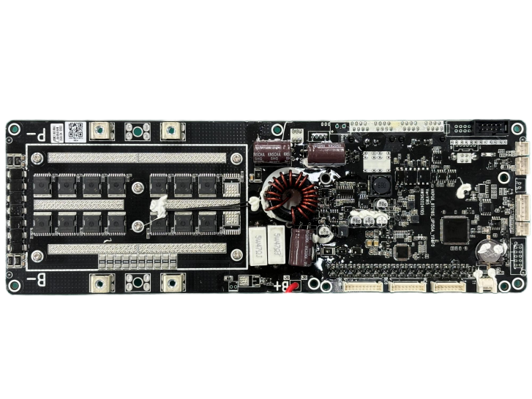

户储保护板-产品介绍
Residential Energy Storage Protection Board - Product Introduction
VKPG7-16S100A-LC10A-F0

版本 Version ：V1.2.1
日期Date：2025/07/07

深圳问鼎新能源技术有限公司
Shenzhen Wending New Energy Technology Co., Ltd.

问鼎VKING BMS
文件更改摘要Document Change Summary
日期  Date | 版本号  Version No. | 修订说明Revision Instruction | 制定人  Prepared by | 核准人  Approved by
2024/05/09 | V1.1 | 第一版First Edition. | QU
202/08/12 | V1.2 | 第二版，改为分体板规格书，增加分体端子板的描述  Second edition: revised as split-board specification, with added description of split terminal board | QU
2025/07/07 | V1.2.1 | 更新页眉 LOGO 及排版格式，内容无实质性修改  The header logo and typesetting format have been updated, with no substantive changes to the content. | 罗漫  Luo Man

产品信息Product Information
客户名称Customer Name
客户型号Customer Model
客户料号Customer Part Number
产品型号  Product Model |  | VKPG7-16S100A-LC10A-F0
版本  Version |  | V1.2.1
日期  Date |  | 2025-07-07
产品清单  Product List  （标配）  (Standard Configuration) |  | 序号  S/N | 名称  Name | 型号  Model |  | 数量  Qty.
 |  | 1 | 分体保护板  Split protection board | VKPG7-16S100A-LC10A-F0 |  | 1pc.
 |  | 2 | 弱电开关线  Weak current switch wire | 2.54MM间距 单头XP HOUSing 26AWG 另一头浸锡长度3MM 线长50cm（XC070）  Single end with a spacing of 2.54MM, XPHOUSing 26AWG, the other end is tinned with a length of 3MM, and the wire length is 50cm (XC070) |  | 1pc.
 |  | 3 | 动力连接线（B+）  香蕉端子  Power connecting wire  Banana Terminal | 动力连接线B+电池端配M6端子环 3.5香蕉母头镀金 标准长度30cm（XC102）  power connecting cable (B+) is equipped with an M6 terminal ring at the battery end, a 3.5mm gold-plated banana female connector, and a standard length of 30cm(XC102) |  | 1pc.
 |  | 4 | 温度采集线  Temperature acquisition wire | 温度采集线(水滴状) 标准长度65cm (XC001)  Temperature acquisition wire (in the shape of a water drop) with standard length of 65cm (XC001) |  | 1pc.
 |  | 5 | 电压采集线BCO~8  Voltage acquisition wire BC0~8 | 电压采集线0-8 标准长度85cm (XC002)  Voltage acquisition wire 0-8 with standard length of 85cm (XC002) |  | 1pc.
 |  | 6 | 电压采集线BC9~16  Voltage acquisition wire BC9~16 | 电压采集线9-16 标准长度85cm（XC003）  Voltage acquisition wire 9-16 with standard length of 85cm (XC003) |  | 1pc.
 |  | 7 | 分体端子VKCGG  Split terminal VKCGG | VKCGG (FTB030) |  | 1pc.
 |  | 8 | 端子板连接线  Terminal block cable | IDC2.54 扁平灰色带扣排线 2*17=34PIN FC34P 500MM 长（XC097）  IDC2.54 gray flat ribbon cable with lock, 2*17=34PIN, FC34P, 500mm length (XC097) |  | 1pc.
问鼎VKING BMS |  |  |  | 客户确认Customer Confirmation
制定  Prepared by |  |  |  | 审查  Reviewed by
核准  Approved by |  |  |  | 核准  Approved by

产品功能配置表 Product Function Configuration Table
标配功能Standard Functions | 序号  S/N | 功能  Function | 定义描述Definition Description | 备注Remarks | 客户  选择  Customer Selection
标配功能Standard Functions | 1 | 存储  Storage | 数据记录>1万条  Data recording > 10,000 pieces
标配功能Standard Functions | 2 | 充电限流  Charging current limiting | 10A（定义：电流＞80A开启）默认不使能  10A (Definition: Activated when current >80A); default disabled
标配功能Standard Functions | 3 | 反接保护  Reverse connection protection | 标配Standard configuration
标配功能Standard Functions | 4 | 弱电开关  Weak current switch | 标配（提供线材和接口,开关客户自行配置）  Standard configuration (Wire and interface are provided, and the switch is configured by the customer)
标配功能Standard Functions | 5 | 蜂鸣器  Buzzer | 标配Standard configuration
标配功能Standard Functions | 6 | LED灯  LED light | 9个LED灯显示面板（定义：1个ALM；1个RUN；1个ON/OFF；6个SOC指示）  9-LED display panel (Definition: 1 ALM, 1 RUN, 1 ON/OFF, 6 SOC indicators)
标配功能Standard Functions | 7 | RGB全彩灯  RGB LED strip | 标配支持RGB全彩灯条，12V供电，单线通讯，WS2815灯珠  Support for RGB LED strip (12V power supply, single-wire communication, WS2815 lamp beads)
标配功能Standard Functions | 8 | RTC时间  RTC time | 标配Standard configuration
标配功能Standard Functions | 9 | USB通讯  USB communication | USB TYPE B方口（定义：上位机接口和软件升级接口）  USB TYPE B square port (Definition: Upper computer interface and software upgrade interface)
标配功能Standard Functions | 10 | RS485-1 | 标配（定义：逆变器通讯口）Standard configuration (Definition: Inverter communication port)
标配功能Standard Functions | 11 | CAN | 标配（定义：逆变器通讯口）Standard configuration (Definition: Inverter communication port)
标配功能Standard Functions | 12 | RS485-2 | 标配（定义：电池包并机口）Standard configuration (Definition: Battery pack parallel port)
标配功能Standard Functions | 13 | 预充功能  Pre-charging function | 标配Standard configuration
标配功能Standard Functions | 14 | 唤醒功能Wake-up function | 标配（定义：实现充电唤醒）Standard configuration (Definition: Achieve charging wake-up)
标配功能Standard Functions | 15 | 拨码功能  DIP function | 四位拨码（电池并机时PACK号选择，1号为主机）  4-bit DIP switch (PACK number selection for battery paralleling, with 1# as the master)
选配功能Customer's signature | 1 | 显示屏  Display screen | 三寸LCD显示屏3-inch LCD display screen
选配功能Customer's signature | 2 | 高清触摸显示屏  High-definition touch screen | 4.3寸高清触摸显示屏（主板需更改电源跳线）  4.3" High-definition touch screen (requires main board power jumper modification)
选配功能Customer's signature | 3 | 干接点  Dry contact | 双路（定义：干接点1常开，故障保护时闭合；干接点2常开，低电量告警闭合）  Dual ways (Definition: Dry contact 1 is normally open and closes during fault protection; dry contact 2 is normally open and closes for low battery alarm)
选配功能Customer's signature | 4 | 拨码选协议  Protocol selection via DIP switch | 选配8位拨码开关（定义：1位选主机或从机；2~6位主机时选通讯协议，从机时选当前电池包地址；7位为RS485-1通讯口末端电阻选择；8位为CAN通讯口末端电阻选择）  Optional 8-bit DIP switch configuration (Definition: bit 1: master/slave selection; bits 2-6: protocol selection for master, or battery pack address for slave; bit 7: selection for RS485-1 end resistor; bit 8: selection for CAN end resistor)
选配功能Customer's signature | 5 | LED灯面板  LED panel | 6个LED灯（定义：1个ALM；1个RUN；4个SOC指示）  6 LED lights (Definition: 1 ALM; 1 RUN; 4 SOC indicators)
选配功能Customer's signature | 6 | 复位按键  Reset button | 1个复位按键（定义：长按4S BMS复位）  1 reset button (Definition: Long press for 4S to reset the BMS)
选配功能Customer's signature | 7 | 支持低串电芯  Support low series battery cells | 支持8~15串电芯电池包  Support battery packs with 8 to 15-series battery cells | 需定制软硬件  Customized hardware and software are required
选配功能Customer's signature | 8 | 加热功能  Heating function | 提供电池供电加热膜接口，控制开启关闭  Provide an interface for the battery-powered heating film and control the on and off | 需定制软硬件Customized hardware and software are required
选配功能Customer's signature | 9 | 二次保护  Secondary protection | 提供电池供电继电器接口，实现二次保护功能  Provide an interface for the battery-powered relay to achieve the secondary protection function | 需定制软硬件Customized hardware and software are required
选配功能Customer's signature | 10 | WIFI模块  WIFI module | 提供WIFI功能和云平台功能  Provide WIFI function and cloud platform function | 需定制软硬件Customized hardware and software are required
选配功能Customer's signature | 11 | 防盗窃模块  Anti-theft module | 防盗窃功能，配合云平台实现远程提醒  Anti-theft function, and achieve remote reminder in cooperation with the cloud platform | 需定制软硬件Customized hardware and software are required
选配功能Customer's signature | 12 | 带灯弱电开关  Illuminated weak-current switch | 预留带灯弱电开关灯的接口  Reserved interface of illuminated weak-current switch | 需定制硬件  Customized hardware required
客户新增需求Customer's new requirements:
客户签字确认Customer's signature：

目录Table of Contents
产品信息Product Information 3
产品功能配置表 Product Function Configuration Table 4
一、 简介 Introduction 9
二、 功能特性 Functional Characteristics 9
三、 功能示意框图Functional Schematic Block Diagram 9
四、 环境要求 Environmental Requirements 10
五、 电气特性 Electrical Characteristics 10
5.1. 基本参数设置 Basic Parameter Settings 10
5.2. LED 指示说明 LED Indication Instructions 13
5.3. 蜂鸣器动作说明Buzzer Action Instructions 15
5.4. 弱电开关说明Weak Current Switch Instructions 15
5.5. 休眠及唤醒Hibernation and Wake-up 15
5.6. 充电限流功能Charging Current Limiting Function 15
5.7. 加热或散热功能（预留）Heating or Cooling Function (Reserved) 16
六、 通信说明Communication Instructions 16
6.1. USB 通信USB Communication 16
6.2. RS485 通信RS485 Communication 16
6.3. CAN 通信CAN Communication 17
6.4. 拨码开关设置DIP Switch Configuration 17
七、 电磁兼容性Electromagnetic Compatibility 20
7.1. 静电放电抗扰性Electrostatic Discharge Immunity 20
7.2. 传导骚扰限值Conducted Emission Limits 20
7.3. 辐射骚扰限值Radiated Emission Limits 21
7.4. 浪涌（冲击）抗扰性Surge (Impact) Immunity 21
八、 接口定义Interface Definition 21
8.1. 通信接口图示Communication Interface Diagram 21
8.2. 电气接口定义Definition of Electrical Interfaces 22
8.3. 安装连接说明Installation and Connection Instructions 23
九、 协议支持Protocol Support 25
十、 实物图与尺寸图 Physical Diagram and Dimension Diagram 26
10.1. 主控板标配图Standard Diagram of Main Control Board 26
10.2. 主板尺寸图Dimension of Main Board 26
10.3. 端子板标配图Standard Diagram of Terminal Board 26
10.4. 端子板尺寸图Terminal Block Dimensions 27
十一、 使用注意事项Precautions for Use 27
附录Appendixes 28

- 简介 Introduction
随着铁锂电池在通信行业的广泛应用，对电池管理系统也提出了高性能、高可靠性及高性价比等要求。本产品是专门针对家庭/后备电池设计的 BMS，采用集成化的设计，将采集、管理、通信等功能集成于一体，可广泛应用在室内室外。
With the wide application of lithium iron phosphate batteries in the communication industry, requirements for high performance, high reliability, and high cost-effectiveness are put forward for the battery management system. This product is a BMS specially designed for household/backup batteries. It adopts an integrated design, integrating functions such as acquisition, management, and communication, and can be widely applied indoors and outdoors.
- 功能特性 Functional Characteristics
➢ 高集成模拟前端  ➢ Highly integrated analog front-end | ➢ 可调过流保护  ➢ Adjustable overcurrent protection
➢ 隔离电源电路  ➢ Isolated power supply circuit | ➢ 具有多种休眠及唤醒方式  ➢ Multiple hibernation/wake-up modes
➢ 集成串口IC  ➢ Integrated serial port IC | ➢ 低功耗  ➢ Low power consumption
➢ 高电压精度 (≤10mV)  ➢ High voltage accuracy (≤10mV) | ➢ RS485/CAN 通信  ➢ RS485/CAN communication
➢ 高电流精度 (≤2%@FS)  ➢ High current accuracy (≤2%@FS) | ➢ 参数可调设置  ➢ Configurable parameters
➢ 4路电池温度检测 (≤2℃)  ➢ 4-way temperature detection (≤2℃) | ➢ 数据刷新时间间隔（周期）≤2秒  ➢ Data refresh interval (cycle) ≤ 2 seconds
➢ SOC 估算功能  ➢ SOC estimation function | ➢ LED 状态指示功能  ➢ LED status indication function
➢ SOH 估算功能  ➢ SOH estimation function | ➢ 具有充电均衡功能  ➢ Charging equalization function
➢ 短路保护功能  ➢ Short-circuit protection function | ➢ SOC 精度(≤5%@50%容量量程以上)  ➢ SOC accuracy (≤5%@50% capacity range)
➢ 并机数据透传，通过主机可访问任意从机  ➢ Data passthrough for parallel operation: The host can access any slave unit. | ➢ OTA 可通过主机批量或指定地址升级从机  ➢ OTA (Over-The-Air): The host supports batch upgrading of slave units or targeted upgrading by specified addresses.
- 功能示意框图Functional Schematic Block Diagram
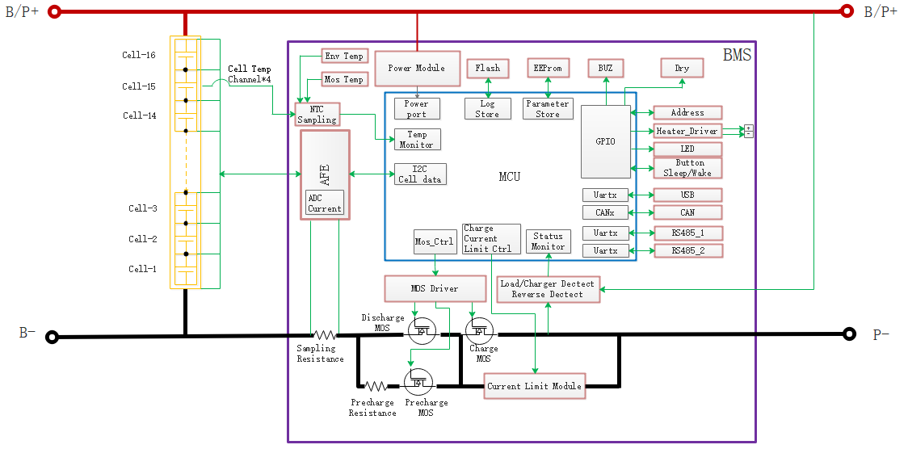
- 环境要求 Environmental Requirements
项目 Item | 参数 Parameter | 单位 Unit
工作温度 Operating temperature | －20～75 | ℃
储存温度 Storage temperature | －20～75 | ℃
工作湿度 Operating humidity | ≤85 | %RH
储存湿度 Storage humidity | ≤95 | %RH
温度测量 Temperature measurement | -40～125 | ℃
大气压力 Atmospheric pressure | 70~106 | kPa
表4-1 环境要求Table 4-1 Environmental Requirements
- 电气特性 Electrical Characteristics
  - 基本参数设置 Basic Parameter Settings
注：以下参数除特殊注明以外，均为25℃环境温度下测试。BMS 对单体电池电压测量范围 0～5V，总电压测量范围范围 0～60V。充放电温升均不应超过 75℃
Note: The following parameters are tested at an ambient temperature of 25℃, unless otherwise specified. The voltage measurement range of a single cell by the BMS is 0-5V, and the total voltage measurement range is 0-60V. The temperature rise during charging and discharging should not exceed 75℃.
序号  S/N | 指标项目 Index Items |  | 出厂默认参数  Factory Default Parameters |  | 是否可设  Whether Adjustable | 备注 Remarks
1 | 单体过充保护Single cell overcharge protection | 单体过充告警电压  Single cell overcharge alarm voltage | 3550±10mV |  | 可设  Yes
1 | 单体过充保护Single cell overcharge protection | 单体过充保护电压  Single cell overcharge protection voltage | 3650mV |  | 可设  Yes
1 | 单体过充保护Single cell overcharge protection | 单体过充保护延时  Single cell overcharge protection delay | 1000mS |  | 可设  Yes
1 | 单体过压保护解除  Single cell overvoltage protection release | 单体过充保护解除电压  Single cell overcharge protection release voltage | 3450±10mV |  | 可设  Yes
1 | 单体过压保护解除  Single cell overvoltage protection release | 容量解除Capacity release | SOC≤96% |  | 可设  Yes
1 | 单体过压保护解除  Single cell overvoltage protection release | 放电解除Discharge release | 放电电流 > 1A  Discharging current >1A
2 | 单体过放保护  Single cell over-discharge protection | 单体过放告警电压  Single cell over-discharge alarm voltage | 2700±10mV |  | 可设  Yes
2 | 单体过放保护  Single cell over-discharge protection | 单体过放保护电压  Single cell over-discharge protection voltage | 2600±10mV |  | 可设  Yes
2 | 单体过放保护  Single cell over-discharge protection | 单体过放保护延时  Single cell over-discharge protection delay | 2000mS |  | 可设  Yes
2 | 单体过放保护  解除Single cell over-discharge protection release | 单体过放保护解除电压Single cell over-discharge protection release voltage | 2800±10mV |  | 可设  Yes
2 | 单体过放保护  解除Single cell over-discharge protection release | 有充电时解除Release when charging | 接入充电器可激活  Activated when the charger is connected
3 | 总体过充保护Overall overcharge protection | 总体过充告警电压Overall overcharge alarm voltage | 56.00V |  | 可设  Yes
3 | 总体过充保护Overall overcharge protection | 总体过充保护电压Overall overcharge protection voltage | 57.60V |  | 可设  Yes
3 | 总体过充保护Overall overcharge protection | 总体过充保护延时Overall overcharge protection delay | 1000mS |  | 可设  Yes
3 | 总体过压保护  解除  Overall overvoltage protection release | 总体过充保护解除电压Overall overcharge protection release voltage | 54.40V |  | 可设  Yes
3 | 总体过压保护  解除  Overall overvoltage protection release | 容量解除Capacity release | SOC≤96% |  | 可设
3 | 总体过压保护  解除  Overall overvoltage protection release | 放电解除Discharge release | 放电电流 > 1A  Discharging current >1A
4 | 总体过放保护Overall over-discharge protection | 总体过放告警电压Overall over-discharge alarm voltage | 44.00V |  | 可设  Yes
4 | 总体过放保护Overall over-discharge protection | 总体过放保护电压Overall over-discharge protection voltage | 42.40V |  | 可设  Yes
4 | 总体过放保护Overall over-discharge protection | 总体过放保护延时Overall over-discharge protection delay | 2000mS |  | 可设  Yes
4 | 总体过放保护  解除Overall over-discharge protection release | 总体过放保护解除电压Overall over-discharge protection release voltage | 45.60V |  | 可设  Yes
4 | 总体过放保护  解除Overall over-discharge protection release | 有充电时解除Release when charging | 接入充电器可激活Activated when the charger is connected
5 | 充电过流保护Charging overcurrent protection | 充电过流告警电流Charging overcurrent alarm current | 105A±1A |  | 可设  Yes | 连续出现 10 次，将锁定该状态，不再自动解除解除  If it occurs continuously for 10 times, the state will be locked and will not be automatically released
5 | 充电过流保护Charging overcurrent protection | 充电过流保护电流Charging overcurrent protection current | 110A±1A |  | 可设  Yes
5 | 充电过流保护Charging overcurrent protection | 充电过流保护延时Charging overcurrent protection delay | 2000mS |  | 可设  Yes
5 | 充电过流保护  解除Charging overcurrent protection release | 自动解除Automatically release | 充电电流 < 100A 5min 后自动解除Automatically release when the charging current is < 100A for 5 minute
5 | 充电过流保护  解除Charging overcurrent protection release | 放电解除Discharge release | 放电电流 > 1A  Discharging current >1A
6 | 放电过流1保护Discharging overcurrent 1 protection | 放电过流1告警电流  Discharging overcurrent 1 alarm current | 105±1A |  | 可设  Yes | 连续出现 3 次，将锁定该状态，不再自动解除If it occurs continuously for 3 times, the state will be locked and will not be automatically released
6 | 放电过流1保护Discharging overcurrent 1 protection | 放电过流1保护电流  Discharging overcurrent 1 protection current | 115±1A |  | 可设  Yes
6 | 放电过流1保护Discharging overcurrent 1 protection | 放电过流1保护延时  Discharging overcurrent 1 protection delay | 1000mS |  | 可设  Yes
6 | 放电过流 1  保护解除Discharging overcurrent 1 protection release | 自动解除Automatically release | 放电电流 < 100A 5min 后自动解除  Automatically release when the discharging current is < 100A for 5 minutes
6 | 放电过流 1  保护解除Discharging overcurrent 1 protection release | 充电解除Charging release | 充电电流 > 1A  Charging current > 1A
7 | 放电过流2保护  Discharging overcurrent 2 protection | 放电过流2保护电流Discharging overcurrent 2 protection current | 125A |  | 可设  Yes | 出现 3 次将锁定该状态，不再自动解除  If it occurs continuously for 3 times, the state will be locked and will not be automatically released
7 | 放电过流2保护  Discharging overcurrent 2 protection | 放电过流2保护延时Discharging overcurrent 2 protection delay | 1000mS |  | 可设  Yes
7 | 放电过流 2  保护解除Discharging overcurrent 2 protection release | 自动解除Automatically release | ——
7 | 放电过流 2  保护解除Discharging overcurrent 2 protection release | 充电解除Charging release | 充电电流 > 1A  Charging current > 1A
8 | 反接保护Reverse connection protection | —— | 无法自动解除，必须关机重启Cannot be automatically released, and the device must be shut down and restarted
9 | 短路保护Short-circuit protection | 短路保护功能  Short-circuit protection function | 有Yes |  |  | 连续出现 5 次 将锁定该状态，不再自动解除If it occurs continuously for 5 times, the state will be locked and will not be automatically released
9 | 短路保护Short-circuit protection | 短路保护解除  Short-circuit protection release | 1min后，短路保护解除Short-circuit protection will be released after 1 minute
10 | MOS 高温保护MOS high temperature protection | MOS 高温告警温度MOS high temperature alarm temperature | 90℃ |  | 可设  Yes
10 | MOS 高温保护MOS high temperature protection | MOS 高温保护温度MOS high temperature protection temperature | 115℃ |  | 可设  Yes
10 | MOS 高温保护MOS high temperature protection | MOS 保护解除温度  MOS protection release temperature | 50℃ |  | 可设  Yes
11 | 电芯温度保护Cell temperature protection | 充电低温告警温度  Charging low temperature alarm temperature | 0℃ |  | 可设  Yes
11 | 电芯温度保护Cell temperature protection | 充电低温保护温度  Charging low temperature protection temperature | -10℃ |  | 可设  Yes
11 | 电芯温度保护Cell temperature protection | 充电低温保护解除温度  Charging low temperature protection release temperature | 5℃ |  | 可设  Yes
11 | 电芯温度保护Cell temperature protection | 充电高温告警温度Charging high temperature alarm temperature | 55℃ |  | 可设  Yes
11 | 电芯温度保护Cell temperature protection | 充电高温保护温度Charging high temperature protection temperature | 65℃ |  | 可设  Yes
11 | 电芯温度保护Cell temperature protection | 充电高温保护解除温度Charging high temperature protection release temperature | 50℃ |  | 可设  Yes
11 | 电芯温度保护Cell temperature protection | 放电低温告警温度Discharging low temperature alarm temperature | -0℃ |  | 可设  Yes
11 | 电芯温度保护Cell temperature protection | 放电低温保护温度Discharging low temperature protection temperature | -20℃ |  | 可设  Yes
11 | 电芯温度保护Cell temperature protection | 放电低温保护解除温度Discharging low temperature protection release temperature | 5℃ |  | 可设  Yes
11 | 电芯温度保护Cell temperature protection | 放电高温告警温度Discharging high temperature alarm temperature | 50℃ |  | 可设  Yes
11 | 电芯温度保护Cell temperature protection | 放电高温保护温度Discharging high temperature protection temperature | 65℃ |  | 可设  Yes
11 | 电芯温度保护Cell temperature protection | 放电高温保护解除温度Discharging high temperature protection release temperature | 50℃ |  | 可设  Yes
12 | 环境温度告警Ambient temperature alarm | 环境低温告警温度Ambient low temperature alarm temperature | -10℃ |  | 可设  Yes
12 | 环境温度告警Ambient temperature alarm | 环境低温保护温度Ambient low temperature protection temperature | -20℃ |  | 可设  Yes
12 | 环境温度告警Ambient temperature alarm | 环境低温保护解除温度Ambient low temperature protection release temperature | -10℃ |  | 可设  Yes
12 | 环境温度告警Ambient temperature alarm | 环境高温告警温度Ambient high temperature alarm temperature | 60℃ |  | 可设  Yes
12 | 环境温度告警Ambient temperature alarm | 环境高温保护温度Ambient high temperature protection temperature | 70℃ |  | 可设  Yes
12 | 环境温度告警Ambient temperature alarm | 环境高温保护解除温度  Ambient high temperature protection release temperature | 50℃ |  | 可设  Yes
13 | 消耗电流Consumption current | 工作时自耗电电流  Self-consumption current during operation | ≤15mA
13 | 消耗电流Consumption current | 低功耗模式电流  Low power consumption mode current | ≤1mA
14 | 均衡功能Equalization function | 均衡开启电压  Equalization activation voltage | 3400mV | 可设  Yes |  | 单体间压差大于1V时，不应启动均衡  When the voltage difference between single cells is greater than 1V, the equalization should not be started
14 | 均衡功能Equalization function | 开启压差  Activation voltage difference | 50mV | 可设  Yes
15 | 容量默认设置Capacity default setting | 低电量告警Low battery alarm | SOC＜5% | 可设  Yes |  | 充电时不告警  No alarm during
16 | 休眠功能Hibernation function | 休眠电压Hibernation voltage | 2600mV | 可设  Yes
16 | 休眠功能Hibernation function | 延迟时间Delay time | 10min | 可设  Yes
17 | 电芯失效保护Cell failure protection | 单体压差Voltage difference between single cells | 压差＞800mV |  |  | 不允许充放电Charging and discharging are not allowed
18 | 满充判断  Full charge judgment | 满充电压Full charge voltage | 58.4V
18 | 满充判断  Full charge judgment | 截止电流Cut-off current | 0.5A
表5-1 参数配置Table 5-1 Parameter Configuration

  - LED 指示说明 LED Indication Instructions
闪灯方式定义Definition of flashing mode
备注：可通过上位机使能或禁止 LED 指示灯告警，出厂默认为使能的。
Note: The LED indicator light alarm can be enabled or disabled through the upper computer, and it is enabled by default when leaving the factory.

运行方式  Operation mode | 亮(秒)  On (seconds) | 灭(秒)  Off (seconds)
闪1  Flash 1 | 0.5 | 3.5
闪2  Flash 2 | 0.5 | 0.5
闪3  Flash 3 | 0.5 | 1.5
表5-2 闪灯模式 Table 5-2 Flashing Mode

    - 6个SOC指示灯SOC indicator lights
各个状态下的闪灯方式定义Definition of the flashing mode in various states：
状态  Status | 正常/告警/保护  Normal/Alarm/Protection | 运行灯  Operation Light | 告警灯  Alarm Light | 电量灯  SOC Lights |  |  |  |  |  | 备注  Remarks
 |  |  |  | 17% | 33% | 50% | 66% | 83% | 100% | 备注  Remarks
关机  Shutdown | 休眠  Hibernation | 灭  Off | 灭  Off | 灭  Off | 灭  Off | 灭  Off | 灭  Off
待机  Standby | 正常  Normal | 闪1  Flash 1 | 灭  Off | 依据电量指示  According to the power indication |  |  |  |  |  | 待机状态  On standby
待机  Standby | 告警  Alarm | 闪1  Flash 1 | 闪3  Flash 3 |  |  |  |  |  |  | 所有告警和保护  All alarms and protections  （不包括过充告警和保护）  (Excluding overcharge alarm and protection)
失效  Failure | 电芯故障  Cell failure | 闪2  Flash 2 | 闪2  Flash 2 | 闪2  Flash 2 | 灭  Off | 灭  Off | 灭  Off | 灭  Off | 灭  Off | 停止充放电  Stop charging and discharging
失效  Failure | 充放电MOS故障  Charging and discharging MOS failure | 闪2  Flash 2 | 闪2  Flash 2 | 灭  Off | 闪2  Flash 2 | 灭  Off | 灭  Off | 灭  Off | 灭  Off | 停止充放电  Stop charging and discharging
失效  Failure | AFE故障  AFE failure | 闪2  Flash 2 | 闪2  Flash 2 | 灭  Off | 灭  Off | 闪2  Flash 2 | 灭  Off | 灭  Off | 灭  Off | 停止充放电  Stop charging and discharging
失效  Failure | 电流采样电阻故障  Current sampling resistor failure | 闪2  Flash 2 | 闪2  Flash 2 | 灭  Off | 灭  Off | 灭  Off | 闪2  Flash 2 | 灭  Off | 灭  Off | 停止充放电  Stop charging and discharging
失效  Failure | 电压故障  Voltage failure | 闪2  Flash 2 | 闪2  Flash 2 | 灭  Off | 灭  Off | 灭  Off | 灭  Off | 闪2  Flash 2 | 灭  Off | 停止充放电  Stop charging and discharging
失效  Failure | 反接故障  Reverse connection failure | 闪2  Flash 2 | 闪2  Flash 2 | 灭  Off | 灭  Off | 灭  Off | 灭  Off | 灭  Off | 闪2  Flash 2 | 停止充放电  Stop charging and discharging
失效  Failure | 短路  Short circuit | 闪2  Flash 2 | 闪2  Flash 2 | 闪2  Flash 2 | 闪2  Flash 2 | 闪2  Flash 2 | 闪2  Flash 2 | 闪2  Flash 2 | 闪2  Flash 2 | 停止充放电  Stop charging and discharging
表5-5 6SOC闪灯含义 Table 5-3 Flashing Meanings of 6 SOC Lights

状态  Status | 充电  Charging |  |  |  |  |  | 放电/待机  Discharging/Standby
容量指示灯  Capacity indicator light | LED1 | LED2 | LED3 | LED4 | LED5 | LED6 | LED1 | LED2 | LED3 | LED4 | LED5 | LED6
0%~17% | 闪2  Flash 2 | 灭  Off | 灭  Off | 灭  Off | 灭  Off | 灭  Off | 常亮  Normally on | 灭  Off | 灭  Off | 灭  Off | 灭  Off | 灭  Off
17%~33% | 常亮  Normally on | 闪2  Flash 2 | 灭  Off | 灭  Off | 灭  Off | 灭  Off | 常亮  Normally on | 常亮  Normally on | 灭  Off | 灭  Off | 灭  Off | 灭  Off
33%~50% | 常亮  Normally on | 常亮  Normally on | 闪2  Flash 2 | 灭  Off | 灭  Off | 灭  Off | 常亮  Normally on | 常亮  Normally on | 常亮  Normally on | 灭  Off | 灭  Off | 灭  Off
50%~66% | 常亮  Normally on | 常亮  Normally on | 常亮  Normally on | 闪2  Flash 2 | 灭  Off | 灭  Off | 常亮  Normally on | 常亮  Normally on | 常亮  Normally on | 常亮  Normally on | 灭  Off | 灭  Off
66%~83% | 常亮  Normally on | 常亮  Normally on | 常亮  Normally on | 常亮  Normally on | 闪2  Flash 2 | 灭  Off | 常亮  Normally on | 常亮  Normally on | 常亮  Normally on | 常亮  Normally on | 常亮  Normally on | 灭  Off
83%~100% | 常亮  Normally on | 常亮  Normally on | 常亮  Normally on | 常亮  Normally on | 常亮  Normally on | 闪2  Flash 2 | 常亮  Normally on | 常亮  Normally on | 常亮  Normally on | 常亮  Normally on | 常亮  Normally on | 常亮  Normally on
运行灯Operation Light | 常亮  Normally on |  |  |  |  |  | 闪3  Flash 3
表5-6 6SOC容量表现方式 Table 5-4 Capacity Representation of 6 SOC Lights

  - 蜂鸣器动作说明Buzzer Action Instructions
- 开机上电，蜂鸣器长鸣一声；When powering on, the buzzer emits a long beep;
- 关机休眠，蜂鸣器短鸣一声；When shutting down and hibernating, the buzzer emits a short beep;
- 短路保护时，蜂鸣器每隔 2S 鸣叫一声,短路保护 3 次锁定后，蜂鸣器不再鸣叫；蜂鸣器功能可通过上位机使能或禁止，出厂默认是禁止的；
In case of short-circuit protection, the buzzer beeps every 2 seconds. After the short-circuit protection is locked for 3 times, the buzzer stops beeping; The buzzer function can be enabled or disabled through the upper computer, and it is disabled by default when leaving the factory;
- 蜂鸣器功能禁止时，在保护板告警和保护时（短路和反接保护除外），蜂鸣器不工作；
When the buzzer function is disabled, the buzzer does not work when the protection board gives an alarm and protection (excluding short-circuit and reverse connection protection);
  - 弱电开关说明Weak Current Switch Instructions
- 当弱电开关常闭状态，BMS保护板正常工作。
When the weak current switch is in the normally closed state, the BMS protection board works normally.
- 当弱电开关常开状态，BMS保护板关机。
When the weak current switch is in the normally open state, the BMS protection board shuts down.
  - 休眠及唤醒Hibernation and Wake-up
    - 休眠Hibernation
为了降低整个系统的功耗，系统具有休眠功能，当满足以下条件时，系统将进入休眠模式：
To reduce the power consumption of the entire system, the system has a hibernation function. When the following conditions are met, the system will enter the hibernation mode:
- 单体过放保护 5 分钟仍未解除（可设置）。
The single cell over-discharge protection has not been released within 5 minutes (can be set).
- 待机状态持续时间达到 24 小时（无通讯、无充放电、无充电机接入，可设置）。
The standby state lasts for 24 hours (no communication, no charging or discharging, no charger connected, can be set).
    - 唤醒Wake-up
结合实际情况，为了方便使用，系统提供了多种不同的唤醒方式：
Combined with the actual situation, for the convenience of use, the system provides multiple different wake-up methods:
- 充电唤醒：接入充电器，充电机电压大于 36V；
Charging wake-up: Connect the charger, and the charger voltage is greater than 36V;
- 自动唤醒：自动唤醒使能，且配置时间大于0，非按键手动关机或者低电量关机；
Automatic wake-up: The automatic wake-up is enabled, and the configured time is greater than 0, and it is not manually shut down by the button or shut down due to low battery;
  - 充电限流功能Charging Current Limiting Function
- 保护板具有充电限流功能，充电限流为10±1A,用户可通过上位机设置限流启动条件和限流功能的开启和关闭。
The protection board has a charging current limiting function, and the charging current limiting is 10±1A. The user can set the current limiting activation condition and the on/off of the current limiting function through the upper computer.
- 充电限流默认启动条件为充电电流大于80A(可设置)，进入限流模式后，充电电流小于2A，或者10分钟后自动退出限流模式。
The default activation condition for charging current limiting is that the charging current is greater than 80A (can be set). After entering the current limiting mode, it will automatically exit the current limiting mode when the charging current is less than 2A or after 10 minutes.
  - 加热或散热功能（预留）Heating or Cooling Function (Reserved)
- 保护板预留充放电加热控制功能（默认不提供），BMS实时监控电芯温度，当电芯温度最小值低于加热开启温度时，保护板启动加热功能，当所有电芯温度达到加热关闭温度时，加热功能关闭；
The protection board reserves the charging and discharging heating control function (not provided by default). The BMS monitors the cell temperature in real time. When the minimum value of the cell temperature is lower than the heating activation temperature, the protection board activates the heating function. When the temperature of all cells reaches the heating shutdown temperature, the heating function is turned off.
- 保护板预留充放电散热控制功能（默认不提供），BMS实时监控电芯温度，当电芯温度最高值大于散热开启温度时，保护板启动散热功能，当所有电芯温度达到散热关闭温度时，散热功能关闭；
The protection board reserves the charging and discharging cooling control function (not provided by default). The BMS monitors the cell temperature in real time. When the maximum value of the cell temperature is greater than the cooling activation temperature, the protection board activates the cooling function. When the temperature of all cells reaches the cooling shutdown temperature, the cooling function is turned off.
- 加热功能最大输出电流为3A，即48V时最大负载能力为150W；
The maximum output current of the heating function is 3A, that is, the maximum load capacity at 48V is 150W.
- 加热与散热功能共用一个控制输出脚，同时只能提供其中一种功能（默认是加热），可以通过用户特性配置该控制脚的功能。
The heating and cooling functions share a control output pin, and only one of the functions can be provided at the same time (heating is provided by default), and the function of this control pin can be configured according to user characteristics.

- 通信说明Communication Instructions
  - USB 通信USB Communication
USB接口采用TYPE B 端口，BMS 可以通过该接口与上位机进行通讯，从而在上位机端监控电池的各种信息，包括电池电压、电流、温度、状态、SOC、SOH 及电池生产信息等，默认波特率为 115200bps。
The USB interface adopts the TYPE B port. The BMS can communicate with the upper computer through this interface, so as to monitor various information of the battery at the upper computer end, including battery voltage, current, temperature, status, SOC, SOH and battery production information, etc. The default baud rate is 115200bps.
  - RS485 通信RS485 Communication
具有2路 RS485 接口It has 2 RS485 communication interfaces:
- RS485-1为单端RJ45网络端口，主要用于电池组与逆变器间的数据交互，默认波特率为 9600bps。
RS485-1 is a single-ended RJ45 network port, which is mainly used for data interaction between the battery pack and the inverter. The default baud rate is 9600bps.
- RS485-2为双端RJ45网络端口，用于电池组的级联并机之间的数据交互，目前并机接口最多可支持32组电池进行并机操作。
RS485-2 is a double-ended RJ45 network port, which is used for data interaction between cascaded parallel battery packs. Currently, the parallel connection interface can support up to 32 groups of batteries for parallel connection operation.
  - CAN 通信CAN Communication
具有1路CAN通信接口,为单端RJ45网络端口，主要用于电池组与逆变器间的数据交互，默认波特率为500K；
It has 1 CAN communication interface, which is a single-ended RJ45 network port and is mainly used for data interaction between the battery pack and the inverter. The default baud rate is 500K.
  - 拨码开关设置DIP Switch Configuration
    - 4位的拨码开关An 4 - position DIP switch
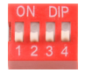
4位的拨码开关只能用于电池包地址的编址，具体的地址映射参见下表：
A 4 - position DIP switch can only be used for addressing the battery pack address. For the specific address mapping, please refer to the following table：
地址Address | 拨码设置DIP settings |  |  |  | 备注Address
地址Address | #1 | #2 | #3 | #4 | 备注Address
1 | OFF | OFF | OFF | OFF | 主电池1  Master battery 1
2 | ON | OFF | OFF | OFF | 从电池2  Slave battery 2
3 | OFF | ON | OFF | OFF | 从电池3  Slave battery 3
4 | ON | ON | OFF | OFF | 从电池4  Slave battery 4
5 | OFF | OFF | ON | OFF | 从电池5  Slave battery 5
6 | ON | OFF | ON | OFF | 从电池6  Slave battery 6
7 | OFF | ON | ON | OFF | 从电池7  Slave battery 7
8 | ON | ON | ON | OFF | 从电池8  Slave battery 8
9 | OFF | OFF | OFF | ON | 从电池9  Slave battery 9
10 | ON | OFF | OFF | ON | 从电池10  Slave battery 10
11 | OFF | ON | OFF | ON | 从电池11  Slave battery 11
12 | ON | ON | OFF | ON | 从电池12  Slave battery 12
13 | OFF | OFF | ON | ON | 从电池13  Slave battery 13
14 | ON | OFF | ON | ON | 从电池14  Slave battery 14
15 | OFF | ON | ON | ON | 从电池15  Slave battery 15
16 | ON | ON | ON | ON | 从电池16  Slave battery 16
表6-4 拨码开关地址Table 6-2 DIP Switch Address

- 电磁兼容性Electromagnetic Compatibility
  - 静电放电抗扰性Electrostatic Discharge Immunity
满足 GB/T 17626.2-2018 等级 4 的要求，接触 8KV，空气 15KV；试验后能正常工作。
It meets the requirements of Grade 4 in GB/T17626.2-2018, with a contact voltage of 8KV and an air voltage of 15KV; It can work normally after the test.
  - 传导骚扰限值Conducted Emission Limits
满足传导骚扰限值应符合表7-1的要求（引自 GB 9254-2008 中第5.1条中表1）；试验后能正常工作。
It meets the requirements of the conducted emission limits as specified in Table 7-1 (quoted from Table 1 in Article 5.1 of GB9254-2008); It can work normally after the test.
频率范围 / MHz  Frequency Range / MHz | 限值Limit / dB(μV)
频率范围 / MHz  Frequency Range / MHz | 准峰值  Quasi-peak Value | 平均值  Average Value
0.15~0.50 | 79 | 66
0.50~30 | 73 | 60
表7-1 传导骚扰限值Table 7-1 Conducted Emission Limits

  - 辐射骚扰限值Radiated Emission Limits
满足辐射骚扰限值应符合表7-2的要求（引自 GB 9254-2008 中第6.1条中表5）；试验后能正常工作。
It meets the requirements of the radiated emission limits as specified in Table 7-2 (quoted from Table 5 in Article 6.1 of GB9254-2008); It can work normally after the test.
频率范围 / MHz  Frequency Range / MHz | 准峰值限值 / dB(μV / m)  Quasi-peak Value Limit / dB(μV/m)
30~230 | 40
230~1000 | 47
表7-2 辐射骚扰限值Table 7-2 Radiated Emission Limits

  - 浪涌（冲击）抗扰性Surge (Impact) Immunity
通信端口和电源端口应采用相应的隔离措施， 通信端口线对线应满足 GB/T 17626.5-2019 等级 2（开路试验电压 0.5kV） 的要求，线对地应满足 GB/T 17626.5-2019 等级 2（开路试验电压 1kV） 的要求；电源端口线对线应满足 GB/T 17626.5-2019 等级 4（开路试验电压 2kV） 的要求，线对地应满足 GB/T 17626.5-2019 等级 4（开路试验电压 4kV）的要求。.
Corresponding isolation measures should be adopted for the communication port and the power port. The line-to-line of the communication port should meet the requirements of Grade 2 in GB/T 17626.5-2019 (open-circuit test voltage of 0.5kV), and the line-to-ground should meet the requirements of Grade 2 in GB/T 17626.5-2019 (open-circuit test voltage of 1kV); The line-to-line of the power port should meet the requirements of Grade 4 in GB/T 17626.5-2019 (open-circuit test voltage of 2kV), and the line-to-ground should meet the requirements of Grade 4 in GB/T 17626.5-2019 (open-circuit test voltage of 4kV).

- 接口定义Interface Definition
  - 通信接口图示Communication Interface Diagram
    - USB 通讯端口定义（接上位机）Definition of USB communication port (connected to the upper computer)
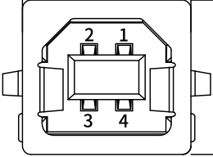
接口Interface | 定义说明Definition Description
X7  通讯端口定义  Definition of the communication port | PIN 1 | VBUS
X7  通讯端口定义  Definition of the communication port | PIN 2 | D-
X7  通讯端口定义  Definition of the communication port | PIN 3 | D+
X7  通讯端口定义  Definition of the communication port | PIN 4 | GND
表8-1 USB端口定义Table 8-1 Definition of the USB Port
    - RS485-2 通讯接口定义Definition of the RS485-2 communication interface
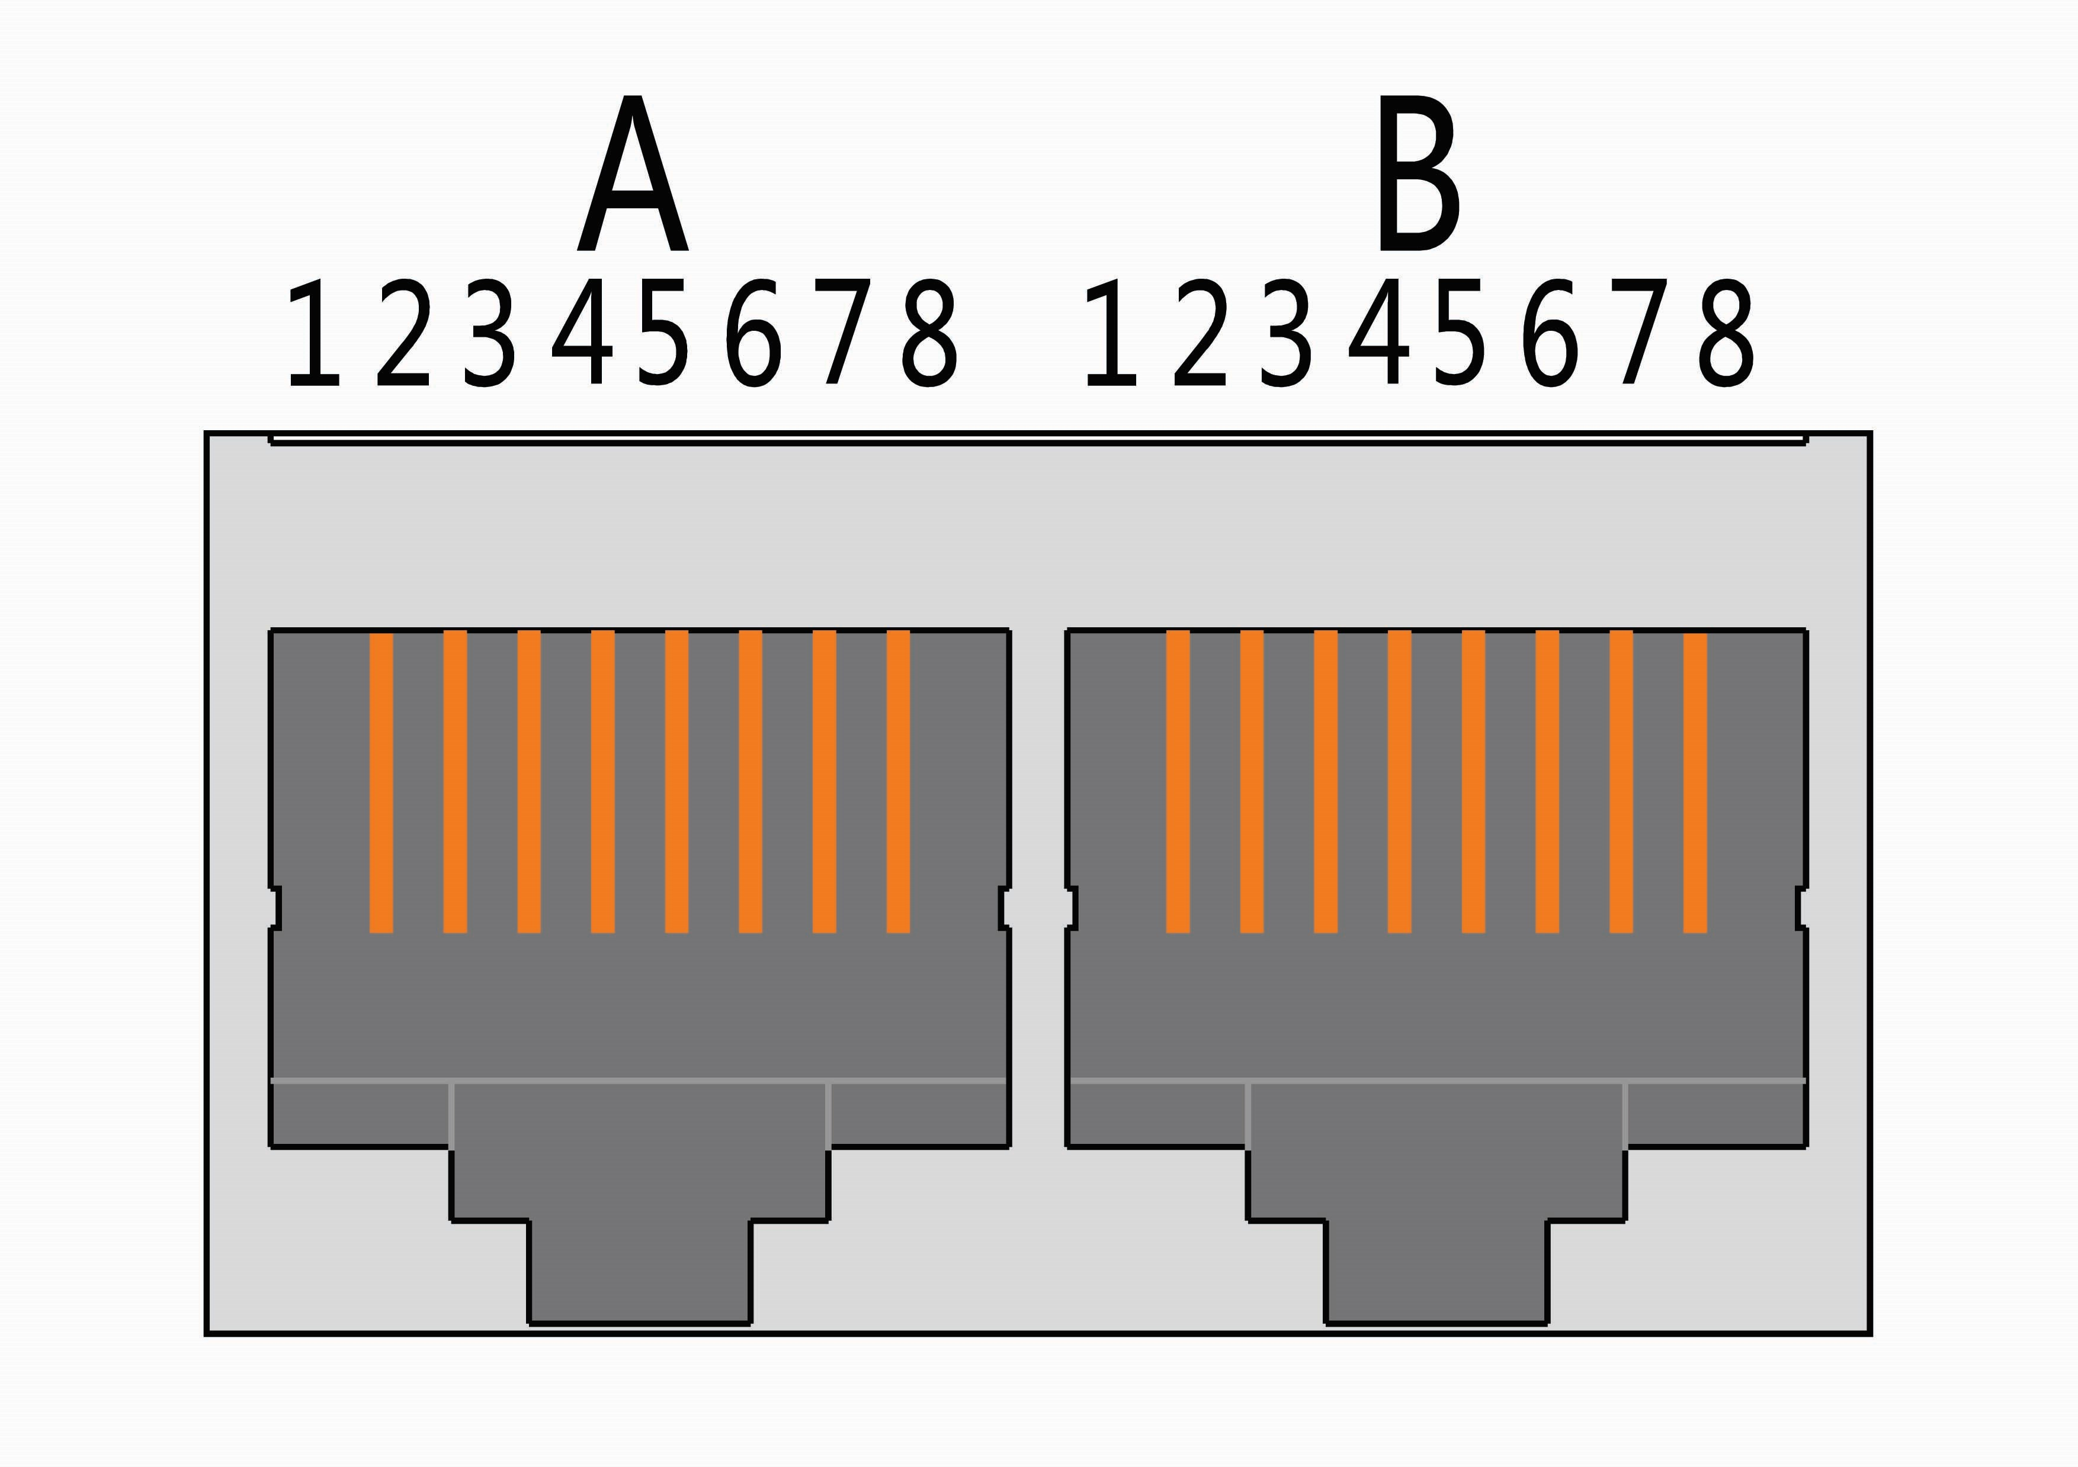
接口Interface | 定义说明Definition Description |  |  | 定义说明Definition Description
X2  通讯端口定义  Definition of the communication port | A部分  Part A  RS485-2  并机接口  Parallel interface | PIN 1 | RS485-B2 | B部分  Part B  RS485-2  并机接口  Parallel interface | PIN 1 | RS485-B2
X2  通讯端口定义  Definition of the communication port | A部分  Part A  RS485-2  并机接口  Parallel interface | PIN 2 | RS485-A2 | B部分  Part B  RS485-2  并机接口  Parallel interface | PIN 2 | RS485-A2
X2  通讯端口定义  Definition of the communication port | A部分  Part A  RS485-2  并机接口  Parallel interface | PIN 3 | GND | B部分  Part B  RS485-2  并机接口  Parallel interface | PIN 3 | GND
X2  通讯端口定义  Definition of the communication port | A部分  Part A  RS485-2  并机接口  Parallel interface | PIN 4 | NC(空)  NC (not connected) | B部分  Part B  RS485-2  并机接口  Parallel interface | PIN 4 | NC(空)  NC (not connected)
X2  通讯端口定义  Definition of the communication port | A部分  Part A  RS485-2  并机接口  Parallel interface | PIN 5 | NC(空)  NC (not connected) | B部分  Part B  RS485-2  并机接口  Parallel interface | PIN 5 | NC(空)  NC (not connected)
X2  通讯端口定义  Definition of the communication port | A部分  Part A  RS485-2  并机接口  Parallel interface | PIN 6 | GND | B部分  Part B  RS485-2  并机接口  Parallel interface | PIN 6 | GND
X2  通讯端口定义  Definition of the communication port | A部分  Part A  RS485-2  并机接口  Parallel interface | PIN 7 | RS485-A2 | B部分  Part B  RS485-2  并机接口  Parallel interface | PIN 7 | RS485-A2
X2  通讯端口定义  Definition of the communication port | A部分  Part A  RS485-2  并机接口  Parallel interface | PIN 8 | RS485-B2 | B部分  Part B  RS485-2  并机接口  Parallel interface | PIN 8 | RS485-B2
表8-2 RS485-2端口定义 Table 8-4 Definition of the RS485-2 Port

    - RS485-1/CAN 通讯接口定义Definition of the RS485-1/CAN communication interface
接口Interface | 定义说明Definition Description |  |  | 定义说明Definition Description
X1  通讯端口定义Definition of the communication port | B部分  Part B  CAN接口  CAN interface | PIN 1 | NC(空not connected) | A部分  Part A  RS485-1接口  RS485-1 interface | PIN 1 | RS485-B1
X1  通讯端口定义Definition of the communication port | B部分  Part B  CAN接口  CAN interface | PIN 2 | GND | A部分  Part A  RS485-1接口  RS485-1 interface | PIN 2 | RS485-A1
X1  通讯端口定义Definition of the communication port | B部分  Part B  CAN接口  CAN interface | PIN 3 | NC(空not connected) | A部分  Part A  RS485-1接口  RS485-1 interface | PIN 3 | GND
X1  通讯端口定义Definition of the communication port | B部分  Part B  CAN接口  CAN interface | PIN 4 | CAN1-H | A部分  Part A  RS485-1接口  RS485-1 interface | PIN 4 | RS485-B1
X1  通讯端口定义Definition of the communication port | B部分  Part B  CAN接口  CAN interface | PIN 5 | CAN1-L | A部分  Part A  RS485-1接口  RS485-1 interface | PIN 5 | RS485-A1
X1  通讯端口定义Definition of the communication port | B部分  Part B  CAN接口  CAN interface | PIN 6 | NC(空not connected) | A部分  Part A  RS485-1接口  RS485-1 interface | PIN 6 | GND
X1  通讯端口定义Definition of the communication port | B部分  Part B  CAN接口  CAN interface | PIN 7 | NC(空not connected) | A部分  Part A  RS485-1接口  RS485-1 interface | PIN 7 | NC(空not connected)
X1  通讯端口定义Definition of the communication port | B部分  Part B  CAN接口  CAN interface | PIN 8 | NC(空not connected) | A部分  Part A  RS485-1接口  RS485-1 interface | PIN 8 | NC(空not connected)
  - 电气接口定义Definition of Electrical Interfaces
接口Interface | 定义说明Definition Description
B+ | BMS 供电端子，接电池组 B+（总正）  BMS power supply terminal, connected to B+ (total positive) of the battery pack
B- | 接电池组 B-（总负）  Connected to the negative terminal (total negative) of the battery pack B
P- | 接充电器或者负载的负端（P-）  Connected to the negative terminal (P-) of the charger or load
CN1(1#)  电芯电压检测接口：1  Cell voltage detection interface: 1 | 接口Interface | 定义Definition
CN1(1#)  电芯电压检测接口：1  Cell voltage detection interface: 1 | CN1-1 | B0（黑色线）B0 (black wire)
CN1(1#)  电芯电压检测接口：1  Cell voltage detection interface: 1 | CN1-2 | B1+
CN1(1#)  电芯电压检测接口：1  Cell voltage detection interface: 1 | CN1-3 | B2+
CN1(1#)  电芯电压检测接口：1  Cell voltage detection interface: 1 | CN1-4 | B3+
CN1(1#)  电芯电压检测接口：1  Cell voltage detection interface: 1 | CN1-5 | B4+
CN1(1#)  电芯电压检测接口：1  Cell voltage detection interface: 1 | CN1-6 | B5+
CN1(1#)  电芯电压检测接口：1  Cell voltage detection interface: 1 | CN1-7 | B6+
CN1(1#)  电芯电压检测接口：1  Cell voltage detection interface: 1 | CN1-8 | B7+
CN1(1#)  电芯电压检测接口：1  Cell voltage detection interface: 1 | CN1-9 | B8+
CN2(2#)  电芯电压检测接口：2  Cell voltage detection interface: 2 | 接口Interface | 定义Definition
CN2(2#)  电芯电压检测接口：2  Cell voltage detection interface: 2 | CN2-1 | B9-（黑色线）B9- (black wire)
CN2(2#)  电芯电压检测接口：2  Cell voltage detection interface: 2 | CN2-2 | B9+
CN2(2#)  电芯电压检测接口：2  Cell voltage detection interface: 2 | CN2-3 | B10+
CN2(2#)  电芯电压检测接口：2  Cell voltage detection interface: 2 | CN2-4 | B11+
CN2(2#)  电芯电压检测接口：2  Cell voltage detection interface: 2 | CN2-5 | B12+
CN2(2#)  电芯电压检测接口：2  Cell voltage detection interface: 2 | CN2-6 | B13+
CN2(2#)  电芯电压检测接口：2  Cell voltage detection interface: 2 | CN2-7 | B14+
CN2(2#)  电芯电压检测接口：2  Cell voltage detection interface: 2 | CN2-8 | B15+
CN2(2#)  电芯电压检测接口：2  Cell voltage detection interface: 2 | CN2-9 | B16+
CN2(2#)  电芯电压检测接口：2  Cell voltage detection interface: 2 | CN2-10 | NC(悬空)  NC (not connected)
CN3  电芯温度检测接口Cell Cell temperature detection interface | 接口Interface | 定义Definition
CN3  电芯温度检测接口Cell Cell temperature detection interface | CN3-1 | NTC1+
CN3  电芯温度检测接口Cell Cell temperature detection interface | CN3-2 | NTC1-
CN3  电芯温度检测接口Cell Cell temperature detection interface | CN3-3 | NTC2+
CN3  电芯温度检测接口Cell Cell temperature detection interface | CN3-4 | NTC2-
CN3  电芯温度检测接口Cell Cell temperature detection interface | CN3-5 | NTC3+
CN3  电芯温度检测接口Cell Cell temperature detection interface | CN3-6 | NTC3-
CN3  电芯温度检测接口Cell Cell temperature detection interface | CN3-7 | NTC4+
CN3  电芯温度检测接口Cell Cell temperature detection interface | CN3-8 | NTC4-
X5  电加热插座（预留）  Electrical heating socket (Reserved) | 接口Interface | 定义Definition
X5  电加热插座（预留）  Electrical heating socket (Reserved) | X5-1 | HEAT（加热控制正端）  HEAT (Positive terminal of heating control)
X5  电加热插座（预留）  Electrical heating socket (Reserved) | X5-2 | P-(加热控制负端)  P- (Negative terminal of heating control)
表8-3 采样线端口定义 Table 8-5 Definition of the Sampling Wire Port

  - 安装连接说明Installation and Connection Instructions
    - 保护板安装和拆除Installation and removal of the protection board
保护板上电有严格的顺序要求，先焊接 B-、P-，B+、P+，依次由低到高的顺序插接电池采样线连接器，上电后需要充电或按键激活。所有连接线安装好后才能加负载或充电器。
There are strict sequential requirements for powering on the protection board. First, weld B-, P-, B+, and P+. Then, insert the battery sampling wire connectors in ascending order. After powering on, it needs to be charged or activated by pressing a button. Load or charger can be added only after all connection wires are installed.
拆除时，先拔掉充电器或负载，依次由高到低的顺序拆卸电池采样线连接器，最后拆卸 B+、P+、B-、P-。PACK组装安装示意图如下：
When removing, first unplug the charger or load, then remove the battery sampling wire connectors in descending order, and finally remove B+, P+, B-, and P-.The PACK Assembly Installation Schematic is shown below:
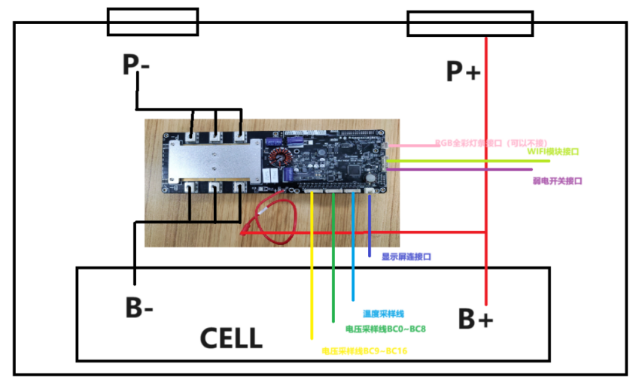

    - 并机接线安装Installation of parallel connection wiring
并机时需要注意只有相同类型和串数的电池包才能相互并联使用，否则不同串数的电池包并联，电池包之间的电压差会导致电池包之间相互放电而无法正常使用。VKPG5版本的硬件用RS485总线实现并机，默认的最大从机数量上限为32，使用标准网线连接，如下图8-1所示：
When making parallel connections, it should be noted that only battery packs of the same type and the same number of series can be connected in parallel. Otherwise, when battery packs with different numbers of series are connected in parallel, the voltage difference between the battery packs will cause mutual discharge between the battery packs, making them unable to be used normally. The VKPG5 hardware achieves paralleling via the RS485 bus, with a default maximum limit of 32 slaves. Connection is made using standard network cables, as shown in Fig. 8-1 below:
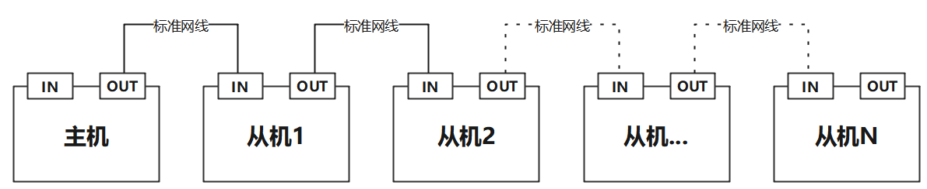
主机
Master
从机1
Slave 1
从机2
Slave 2
从机…
Slave...
从机N
Slave N
标准网线
Standard network cable
标准网线
Standard network cable
标准网线
Standard network cable
标准网线
Standard network cable
图8-1 并机接线示意图Fig. 8-1 Schematic Diagram of Parallel Connection Wiring
建议所有从机地址应该连续，以提高主机扫描从机的效率。开机时先开从机，最后再开主机。主机开机后或自动开始扫描从机，并根据扫描结果确定最大从机的数量， 注：主机锁定从机数量后，不会再改变，如果出现没有扫描到从机的情况，可以先确认从机已开机，然后再重启主机观察。
All slave addresses should be consecutive to improve master scanning efficiency. First power on all slaves, then the master last. After power-up, the master automatically scans for slaves and determines the maximum number of slaves based on the scan results. Note: Once the master locks the number of slaves, it will not change. If no slaves are detected, verify that all slaves are powered on, then restart the master to observe.

- 协议支持Protocol Support
如第6章所述，本保护板的RS485和CAN通信端口可支持多种逆变器协议，具体协议详见下表；
As described in Chapter 6, the RS485 and CAN communication ports of this protection board can support multiple inverter protocols, and the specific protocols are shown in the following table;
如有新协议需求，可联系公司技术人员定制。If there are new protocol requirements, you can contact the company's technicians for customization.
协议  Protocol | 缩写  Abbreviation | 中文名  Chinese Name | RS485 可用  RS485 Available | 版本  Version | CAN可用  CAN Available | 版本  Version
NONE | “NONE” |  | 是Yes | 0.0 | 是Yes | 0.0
VKING | “VKIN” | 问鼎 | 是Yes | 1.0 | 是Yes | 1.0
VOLTRONIC | “VLTC” | 日月元 | 是Yes | 1.0
GROWATT | “GRWT” | 古瑞瓦特 | 是Yes | 2.01 | 是Yes | 1.5
SOLAX | “SOLX” | 艾罗 | 是Yes | 1.2 | 是Yes | 1.2
LTW | “LTW” | 力通威
PACE | “PACE” | 沛城 | 是Yes | 1.3
MUST | “MUST” | 美世乐 | 是Yes | 1.1 | 是Yes | 1.0
SRNE | “SRNE” | 硕日 | 是Yes | 1.0
SMK | “SMK” |  | 是Yes
AFORE | “AFOR” | 艾伏 | 是Yes | 1.0 | 是Yes | 2.1
GOODWE | “GDWE” | 固德威 |  |  | 是Yes | 1.5
SOFAR | “SOFA” | 首航 |  |  | 是Yes | 1.0
LUXPOWER | “LXPR” | 鹏城 |  |  | 是Yes | 1.0
VICTRON | “VICT” |  |  |  | 是Yes | 1.0
PYLON | “PYLN” | 派能 | 是Yes | 1.0 | 是Yes | 1.2，2.0
SOROTEC | “SRTC” | 索瑞德 |  |  | 是Yes | 1.0
SMA | “SMA” |  |  |  | 是Yes | 1.0
GINLONG | “GNLG” | 锦浪 |  |  | 是Yes | 1.0
DONNERGY | “DONN” | 大能 |  |  | 是Yes | 1.0
SOLARFAM | “SLFM”
IMEON | “IMON” |  |  |  | 是Yes | 1.0
SCHNEIDER | “SHDR” | 施耐德 |  |  | 是Yes | 2.0
GENIXGREEN | “GENI” |  | 是Yes(VKING) | 1.0 | 是Yes | 1.0，3.0
INHENERGY | “INHE” | 银河耐吉 |  |  | 是Yes | 1.0
BITTA | “BITA” | 比瓦特 | 是Yes | 1.1
STONE | “STON” | 石头 | 是Yes | 2.1
SENERGY | “SENR” | 盛能杰 |  |  | 是Yes | 1.2
SUNWAYS | “SNWY” | 尚唯斯 |  |  | 是Yes | 2.0
STUDER | “STDR” |  |  |  | 是Yes | 1.0
EVEPER | “EPVR” | 汇能精电 | 是Yes | 1.5
INVT | “INVT” | 英威腾 |  |  | 是Yes | 1.2
KSTAR | “KSTR” | 科士达 | 是Yes | 5.0 | 是Yes | 1.18
SUNFLY | "SNFL" | 昇辉 | 是Yes | 1.2
DEYE | "DEYE" | 德业 |  |  | 是Yes | 1.0
ALTENERGY | "AEPS" | 昱能 |  |  | 是Yes | 1.6

- 实物图与尺寸图 Physical Diagram and Dimension Diagram
  - 主控板标配图Standard Diagram of Main Control Board
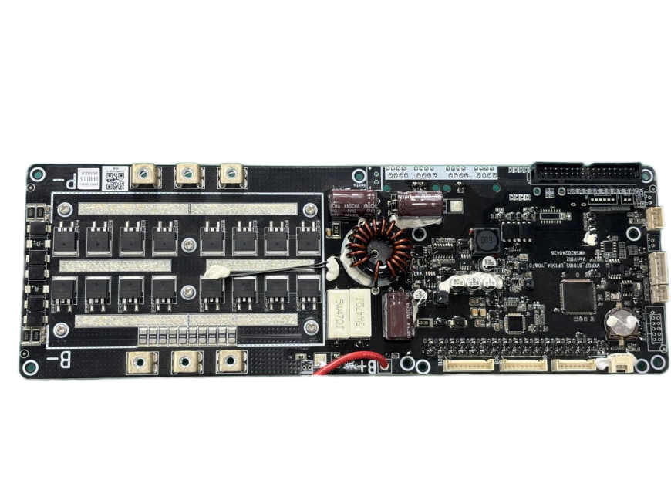
图10-1 主板标配实物图-正面Fig. 10-1 Physical Diagram of the Standard Configuration of the Main Board - Front
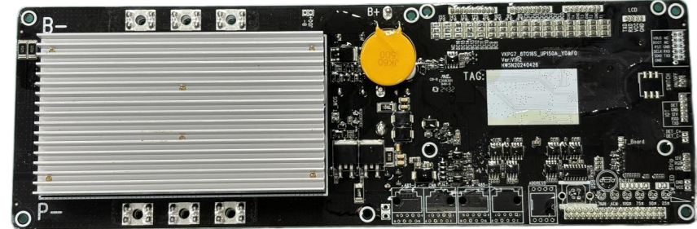
图10-2 主板标配实物图-反面Fig. 10-2 Physical Diagram of the Standard Configuration of the Main Board - Back

  - 主板尺寸图Dimension of Main Board
尺寸Dimension：300(L)*100(W) （单位Unit：mm）
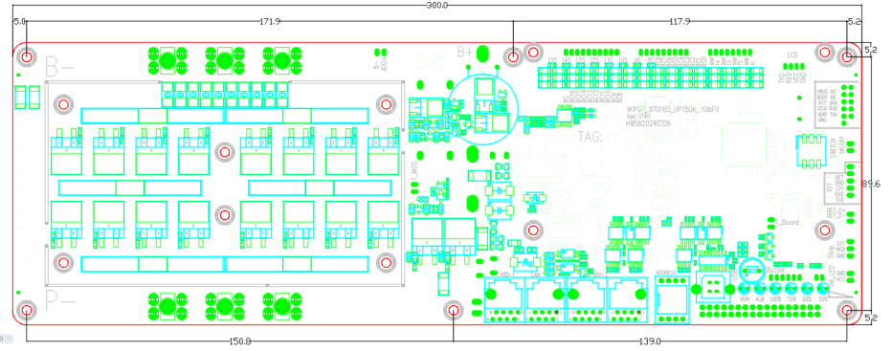
图10-3 主板尺寸图Fig. 10-3 Dimension Diagram of the Main Board

  - 端子板标配图Standard Diagram of Terminal Board
尺寸Dimension：160(L)*45(W)（单位Unit：mm）
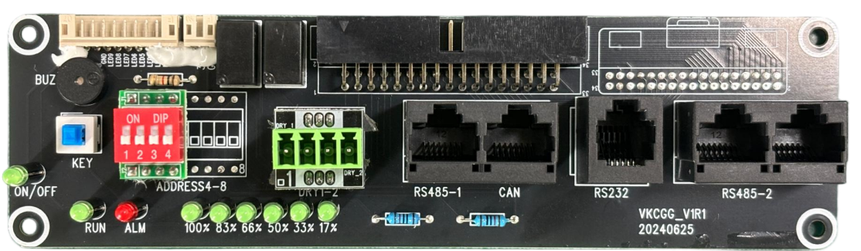
图10-4 端子板标配实物图-正面Fig. 10-4 Physical Diagram of the Standard Terminal Board - Front

- 使用注意事项Precautions for Use
- 焊接电池引线时，一定不可有错接或反接。如果确实已接错，这块电路板可能已损坏，需要重新测试合格后才可使用。When welding the battery lead wires, there must be no wrong connection or reverse connection. If it is indeed wrongly connected, this circuit board may be damaged and can only be used after being retested and passing the test.
- 装配时保护板不要直接接触到电芯表面，以免损坏电芯。正确的装配步骤为，先接电池组B-线，再接上温度采样线，显示屏连接线，然后将电池电压采样线，从低到高，按顺序依次接上，最后接上电池组B+线。拆除BMS时，请按照相反的顺序操作。During assembly, the protection board should not directly contact the surface of the battery cells to avoid damaging the cells. The correct assembly steps are to first connect the B- wire of the battery pack, then connect the temperature sampling wire and the display connection wire, then connect the battery voltage sampling wire in ascending order, and finally connect the B+ wire of the battery pack. When removing the BMS, please operate in the reverse order.
- 使用中注意引线头、烙铁、焊锡等不要碰到电路板上的元器件，否则有可能损坏本电路板。
During use, pay attention that the lead wire heads, soldering irons, solder, etc. should not touch the components on the circuit board, otherwise this circuit board may be damaged.
使用过程要注意防静电、防潮、防水等。Pay attention to preventing static electricity, moisture, water, etc. during use.
- 使用过程中请遵循设计参数及使用条件，不得超过本规格书中的值，否则有可能损坏保护板。
During use, please follow the design parameters and usage conditions, and do not exceed the values specified in this manual, otherwise the protection board may be damaged.
- 将电池组和保护板组合好以后，初次上电如发现无电压输出或充不进电，请检查接线是否正确。
After assembling the battery pack and the protection board, if there is no voltage output or the battery cannot be charged during the initial power-on, please check whether the wiring is correct.
- 部分线缆，螺丝，螺母等配件需要客户行采购，以下列表供参考：
Some accessories such as cables, screws, and nuts need to be purchased by the customer. The following list is for reference.
序号  S/N | 名称  Name | 状态  Status | 备注  Remarks
1 | 上位机通讯线（打印机通讯线）  Communication cable for the upper computer (Printer communication cable) | 需要客户自行采购  To be purchased by the customer
2 | RS485-1 通信接线  RS485-1 communication wiring | 需要客户自行采购  To be purchased by the customer
3 | CAN 通信接线  CAN communication wiring | 需要客户自行采购  To be purchased by the customer
4 | RS485-2 通信接线  RS485-2 communication wiring | 需要客户自行采购  To be purchased by the customer | 标准网线  Standard network cable
6 | 干接点通信接线  Dry contact communication wiring | 需要客户自行采购  To be purchased by the customer
7 | 主板固定螺丝，螺母  Set screws and nuts for the main board | 需要客户自行采购  To be purchased by the customer
8 | B-,P-节点固定螺丝，螺母  Set screws and nuts for the B- and P- nodes | 需要客户自行采购  To be purchased by the customer
表11-1 客户自行采购配件说明Appendix 11-1 Instructions for Accessories Purchased by the Customer

附录Appendixes
附表1：选配件清单Appendix: 1 List of Optional Accessories
序号  S/N | 名称  Name | 型号  Model | 备注  Remarks
1 | 显示屏  Display screen | 各尺寸触摸功能LCD显示屏  Touchscreen LCD displays (various sizes) | 需定制软硬件  Customized hardware and software are required
2 | LED灯面板  LED panel | 9个LED灯显示面板（定义：1个ALM；1个RUN；1个ON/OFF；6个SOC指示）  9-LED display panel (Definition: 1 ALM, 1 RUN, 1 ON/OFF, 6 SOC indicators)
3 | 显示屏  Display screen | 4.3寸彩色触摸显示屏  4.3" color touchscreen display | 需定制软硬件  Customized hardware and software are required
4 | WIFI模块  WIFI module | 提供WIFI功能和云平台功能  Provide WIFI function and cloud platform function | 需定制软硬件  Customized hardware and software are required
5 | 加热功能  Heating function | 提供电池供电加热膜接口，控制开启关闭  Provide an interface for the battery-powered heating film and control the on and off | 需定制软硬件  Customized hardware and software are required
6 | 二次保护  Secondary protection | 提供电池供电继电器接口，实现二次保护功能  Provide an interface for the battery-powered relay to achieve the secondary protection function | 需定制软硬件  Customized hardware and software are required
7 | 支持低串电芯  Support low series battery cells | 支持8~15串电芯电池包  Support battery packs with 8 to 15-series battery cells | 需定制软硬件  Customized hardware and software are required
8 | 防盗窃模块  Anti-theft module | 防盗窃功能，配合云平台实现远程提醒  Anti-theft function, and achieve remote reminder in cooperation with the cloud platform | 需定制软硬件  Customized hardware and software are required
9 | 弱电开关灯  Weak current switch LED | 带灯的弱电开关，提供亮灯接口  Weak current switch with LED indicator (including lighting interface) | 需定制软硬件  Customized hardware and software are required
10 | 硬件弱电开关  Hardware weak current switch | 完全关断BMS供电，实现超低待机功耗  Fully shuts down BMS power for ultra-low standby power consumption | 需定制软硬件  Customized hardware and software are required
附表1 选配件清单Appendix 1 List of Optional Accessories

